GREEN LAKE COUNTY
VETERANS SERVICE COMMISSION

April 11, 2023

The following are the open minutes of the Quarterly Meeting of the Green Lake County Veterans Service Commission held in the Veterans Service Office at the Government Center, Green Lake, WI, at 10:30 A.M. on April 11, 2023

Members present: Victor Shrock, Robert Burdick, Robert Mosolf and Jon Vandeyacht, Secretary.

Certification of Open Meeting Law: The requirements of the Open Meeting Law have been met.

Call to Order: The meeting was called to order at 10:30 A.M. by Chairman Shrock.

Pledge of Allegiance: The Pledge of Allegiance to the Flag was recited.

Approval of Agenda: After discussion, Burdick made a motion to approve the agenda. Second by Mosolf. All ayes. Motion carried.

Action on Minutes: After discussion, Mosolf made a motion to approve the minutes of the January 10, 2023 meeting. Second by Burdick. All ayes. Motion carried.

Appearances & Correspondence: None

Old Business:
Vandeyacht reported that the Wisconsin CVSO Association will be having a spring conference in Madison during the first week of June. It is a National CVSO conference so both himself and Robin will be in attendance this spring.

Vandeyacht reported the Robert Burdick was reappointed for a new 3 year term as service commissioner.

Vandeyacht reported the 2023 Student Government Day is set and ready to go. It will be next week on Tuesday..

Vandeyacht reported that he will be conducting outreach in various parts of the county over the summer months of 2023. Along with the fair, he will be at various VSO programs with a benefits table. 2022 was successful in reaching Veterans that haven’t previously interreacted with the office or has been more than 10 years since the last time.

Vandeyacht reported that the CVSO office received $14,000 from a special grant from WDVA as part of their sharing ARPA funds. They are to be spent by end of year 2024. He is working with other CVSO’s for best ideas on how to legally spend the funds.

New Business: Vandeyacht reported that the 2023 County fair is currently in its planning phase. The CVSO office will have a booth at the fair as usual.

Vandeyacht reported that one of the two volunteer drivers has decided to hang up his keys. Physical problems are making it more difficult to drive and the driver doesn’t want to risk an accident. He is currently seeking a new volunteer driver or two.

Service Office Report: Vandeyacht reported that 2023’s contacts have been significantly increased since the beginning of the year. With the passage of the PACT act granting new presumptive disabilities for Agent Orange exposed as well as the many presumptive for toxic exposure in the middle east, Many Veterans are calling to get more information as well as claims being filed.

Vandeyacht reported he will be out of the office for the week immediately following the week long conference in June. Robin will take care of operations in his absence.

Financial Report: After discussion, Burdick made a motion to approve the Financial Report as submitted. Second by Shrock All ayes. Motion carried.

Future Meeting Date: The date for the next meeting will be Tuesday, Jul 11, 2023 at 10:30

Adjournment: The meeting adjourned at 11:10 A.M. on a motion by Burdick. Second by Shrock. All ayes. Motion carried.

Respectfully submitted:

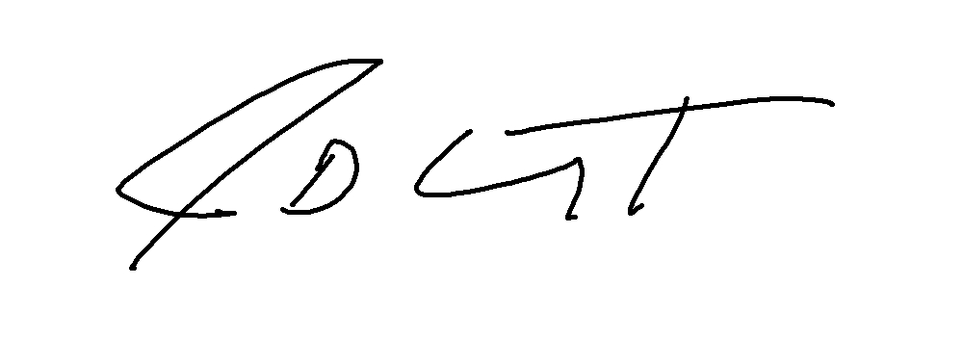

Jon D. Vandeyacht
Secretary, Veterans Service Commission

