PROPERTY AND INSURANCE COMMITTEE
December 7, 2021

The meeting of the Property and Insurance Committee was called to order by Chair Abendroth on Tuesday, December 7, 2021 at 4:00 PM in the Green Lake County Board Room, Green Lake County Government Center, 571 County Road A, Green Lake, WI. The meeting was held both in person and via Zoom. Requirements of the open meeting law were certified as being met. The pledge of allegiance was recited.

Present: Dave Abendroth
Chuck Buss
Patti Garro
Richard Trochinski
Keith Hess

Other County employees present: Scott Weir, Maintenance Supervisor; Liz Otto, County Clerk; Dawn Klockow, Corporation Counsel (Zoom); Jason Jerome, HHS Director; Matt Vandekolk, Chief Deputy

MINUTES
Motion/second (Hess/Trochinski) to approve the minutes of November 2, 2021 with no corrections or updates. Motion carried with no negative vote.

PUBLIC COMMENT - none

APPEARANCES
- Buck Krueger, Cottingham and Butler – Update on 2022 insurance other than health insurance

Buck Krueger and Jacob Heins appeared via Zoom to give a presentation and overview of the bids received for the property and casualty coverage for 2022. The best quote received so far is from EMC with a 25% flat dividend for the work comp coverage and no deductible fund required. Heins stated he would like to negotiate further and will have firm figures for the committee in the next week. A special meeting will be called when the figures are available.

RESOLUTIONS
- Resolution to Change Insurance Carrier

No action taken until the final quotes are received.

PURCHASE OF EQUIPMENT – HHS Freezer
HHS Director Jason Jerome stated that the freezer is for the food pantry and will be paid for through grant funding. HHS is recommending the purchase through Moriarty Refrigeration at a cost of $5,573 which includes delivery and setup.

Motion/second (Hess/Garro) to approve the purchase of a freezer from Moriarty Refrigeration Sales & Service for $5,573. Motion carried with no negative vote.

MAINTENANCE REPORT
- Buildings and Grounds Report – No updates
- Monthly activities

COMMITTEE DISCUSSION
Future Meeting Date: TBD determined based on property & casualty quotes, next regular meeting will be January 4, 2022 at 4:30 PM
Future Agenda items for action & discussion:

ADJOURNMENT

Chair Abendroth adjourned the meeting at 5:01 PM.

Submitted by,
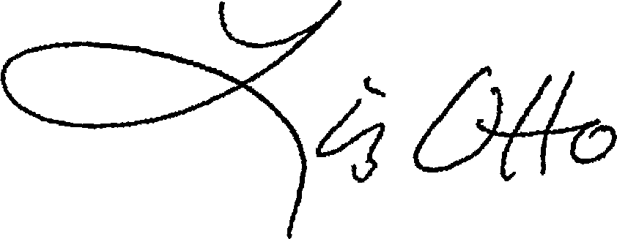
Liz Otto
County Clerk

