GREEN LAKE COUNTY
VETERANS SERVICE COMMISSION

July 13, 2021

The following are the open minutes of the Quarterly Meeting of the Green Lake County Veterans Service Commission held in the Veterans Service Office at the Government Center, Green Lake, WI, at 10:30 A.M. on April 13, 2021

Members present: Victor Shrock, Robert Burdick, Robert Mosolf and Jon Vandeyacht, Secretary.

Certification of Open Meeting Law: The requirements of the Open Meeting Law have been met.

Call to Order: The meeting was called to order at 10:30 A.M. by Chairman Shrock.

Pledge of Allegiance: The Pledge of Allegiance to the Flag was recited.

Approval of Agenda: After discussion, Burdick made a motion to approve the agenda. Second by Mosolf. All ayes. Motion carried.

Action on Minutes: After discussion, Burdick made a motion to approve the minutes of the April 13, 2021 meeting. Second by Mosolf. All ayes. Motion carried.

Appearances & Correspondence: None

Old Business:
Vandeyacht reported that the plan for Veteran outreach has been going well. There have been more than expected new-to-office Veteran contacts made with many of them coming to the office later. Will continue with plan thru the end of the summer.

Vandeyacht reported the 2021 fair was going to happen. As in past years, will have a booth. The difference with this year will be more mobility. Walking around the fair area with military related apparel to start discussions with other veterans on site that don’t stop at the booth.

New Business: Vandeyacht reported the 2022 budget planning cycle is starting. He will work on the proposal and get it submitted after the fair is complete. At this time, there hasn’t been a request to reduce the overall budget.

Vandeyacht Reported that the Wisconsin CVSO association is planning on having an in-person only conference for fall, October 11-15 in Fond du Lac. Both he and his assistant are required to attend training in order to maintain their accreditations with the VA

Vandeyacht reported that the CVSO grant from WDVA was increased with the signing of the latest state biannual budget. He doesn’t plan on making budget adjustments until he sees the new values in writing from WDVA.

Vandeyacht reported that he has not heard anything about the Annual fall Veteran Service Commission meeting that has been traditionally held at King Veterans Home. He will reach out to the Service Commission members if he receives any information on if/when there will be one in 2021.

Service Office Report: Vandeyacht reported that 2021’s contacts have seen a significant increase as compared to 2020’s. There has been a large increase in claims assistance requests with many of them finished within 5 months. The request for service commission emergency aid is still low, but, there are still many protections in place due to Covid

Vandeyacht reported that there are already a large number of claims in process this year this year for the 3 new presumptives to Agent Orange disabilities. He has spread the word for Vietnam Veterans with any of the new presumptives to reach out to the office and file a claim.

Financial Report: After discussion, Burdick made a motion to approve the Financial Report as submitted. Second by Mosolf All ayes. Motion carried.

Future Meeting Date: The date for the next meeting will be Tuesday, Oct 19, 2021 at 10:30

Adjournment: The meeting adjourned at 11:10 A.M. on a motion by Burdick. Second by Mosolf. All ayes. Motion carried.

Respectfully submitted:

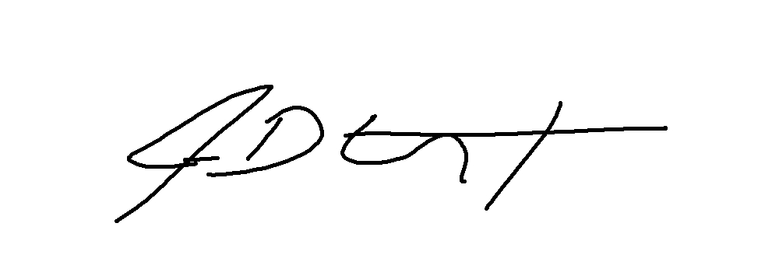
Jon D. Vandeyacht
Secretary, Veterans Service Commission

